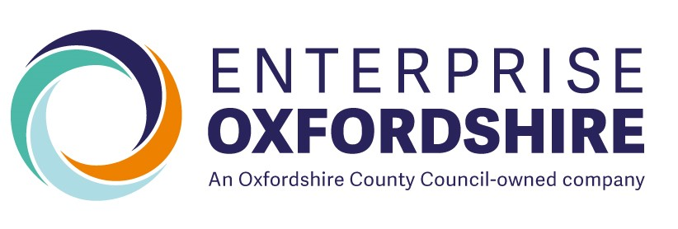

Annex A Skills Bootcamp Wave 6 Application Form

|  |  |
| --- | --- |
| **Skills Bootcamp Organisation Information** | |
| **Lead Organisation Name** |  |
| **UKPRN** |  |
| **Lead Organisation Address** |  |
| **Lead Contact Name** |  |
| **Lead Contact Position** |  |
| **Lead Email Address** |  |
| **Lead Contact Number** |  |

|  |  |
| --- | --- |
| **Summary of Skills Bootcamp Information** | |
| **Skills Bootcamp Title** |  |
| **Level** |  |
| **Proposed Learner Numbers** |  |
| **Indicative Number Split**  **Individual (Unemployed)**  **Employed** **(Co- funded)**  **Self Employed** |  |
|  |
|  |
| **Total Cost Per Learner**  ***(Before Employer Contribution)*** |  |
| **Delivery Location**  ***(Online, Face-face or blended)*** |  |

| **Number** | **Question** | **Weighting** |
| --- | --- | --- |
| **1** | **Experience in delivering Skills Bootcamps**  Please describe your experience of delivering Skills Bootcamps or relevant employer-led training.  **Your answer must include:**   * Experience of delivering training in this sector * Experience of delivering employer led training or Skills Bootcamps focusing on the higher-level skills * Experience of supporting learners to achieve job outcomes * Previous performance achieved, specifically numbers of Milestone 3 outcomes and achieved Milestone 1 starts. * Who was the contract with, DfE national or Local Authority   **Maximum word count:** 750 | **15%** |
|  | **Response:** |  |
| **2** | **Employer Engagement**  Outline your strategy for engaging employers and ensuring that learners achieve positive outcomes, inline with the programme’s KPIs.   * 100% Guaranteed Interview * A minimum of 75% employment outcomes   **Your answer must include:**   * Your plan and resources to drive employer engagement and source vacancies to secure positive outcomes for learners * How will you utilise existing partnerships to enhance the achievement of positive outcomes * How you will ensure that employers actively engaged in your programme remain engaged throughout delivery * How you will encourage SME involvement to support the Skills Bootcamps Programme level target of 60% SME involvement.   **Maximum word count:** 800 | **20%** |
|  | **Response:** |  |
| **3** | **Skills Bootcamp Curriculum**  Explain how your Skills Bootcamp curriculum will equip learners with the technical and employability skills needed to progress into employment within the targeted sector.  **Your answer must include:**   * How the curriculum aligns with current and future skills needs in the sector * Any employer input or validation used in designing the curriculum content * How employability (e.g. CV Writing, interview preparation, communication, teamwork, digital literacy) will be embedded into the training * How have you tested your proposed Skills Bootcamp model with employers to ensure that at least 75% will have a realistic chance of securing employment in this occupation * What accredited qualifications have been included in the Skills Bootcamp and what technical skills and industry standards do they cover.   **Maximum word count:** 750 | **10%** |
|  | **Response:** |  |
| **4** | **Training and Delivery Model**  Describe your proposed training and delivery model for the Skills Bootcamps, ensuring it meets the programme requirements and is accessible, effective, and aligned to sector needs.  **Your answer must include:**   * In-person or online * You must explain your rationale for which elements of curriculum are better suited to online or in person * Outline where you will deliver the in-person elements of your Skills Bootcamp training. * How you will manage catch up sessions for learners who miss a session * How you will monitor and support learner progress throughout the programme   **Maximum word count:** 700 | **5%** |
|  | **Response:** |  |
| **5** | **Recruiting and Onboarding Learners**  Explain your approach to recruiting and onboarding learners onto the Skills Bootcamp, ensuring eligibility, diversity, and readiness for progression.  **Your answer must include:**   * Your recruitment strategy for attracting learners from diverse backgrounds * How you will assess learner suitability and sector interest before enrolment * Your onboarding process, including how you will ensure learners understand the commitment, expectations, and progression opportunities * Your process of managing unsuitable applicants and signposting them to alternative provision where appropriate * Any partnerships or outreach activity planned to support learner recruitment (e.g. community organisations, Jobcentre Plus, employers)   **Maximum word count:** 800 | **12.5** |
|  | **Response:** |  |
| **6** | **Data Management, Evidencing and ILR Reporting**  Explain how you will ensure accurate data collect, evidencing and timely reporting throughout the contract, including the use of the individualised Learner Record (ILR).  **Your answer must include:**   * Your approach to collecting and maintaining accurate learner data throughout the programme * How you will use ensure the standard forms and templates provided by us, ensuring that all documents are completed correctly, signed (wet or verified e-signature), and submitted on time * Your process for submitting complaint and accurate ILR Returns * Your approach to timely milestone claims and evidence submission across all cohorts * They systems and internal quality assurance processes you will use to manage compliance, data security and audit readiness   **Maximum word count:** 800 | **12.5** |
|  | **Response:** |  |
| **7** | **Mobilisation and Delivery Timeline**  Please outline how your mobilisation and delivery timeline will achieve:  **Learner Starts:**   * 10% of learners started by 30th September 2025 * 30% of learners started by 28th November 2025 * 100% of learners started by 30th January 2025   **Learner Completion:**   * 100% of learner completions must be achieved by the 31st March 2026   **Learner Outcomes:**   * 100% learner outcomes must be achieved by 30th September 2026 | **5%** |
|  | **Response:** |  |
| **8** | **Social Value and Sustainability**  Describe how your organisation will create social value and embed sustainability practices throughout the delivery of this Skills Bootcamp. Your response should include:   * How your delivery will contribute to the local community, economy, and environment. * Actions you will take to support diversity, inclusion, and equality of opportunity—particularly for underrepresented groups. * Any initiatives that promote sustainable practices and minimise environmental impact. * How you will collaborate with local employers, voluntary organisations, or community partners to generate lasting social benefit.   Please provide specific examples, measurable outcomes, and how progress will be monitored.  **Maximum word count: 5**00 | **10%** |
|  | **Response:** |  |

|  |  |
| --- | --- |
| **Declaration** | |
| **Full Name** |  |
| **Signature** |  |
| **Date** |  |